

Submitted By AIRLINQ INC.

GMSA Reports Design Document

# PROPRIETARY INFORMATION

The information contained herein is proprietary to Airlinq Inc. Use or disclosure of this document or the information contained herein, for any purpose other than that for which it was furnished is not permitted or it shall not be disclosed or divulged to any third Party without the prior written consent of Airlinq Inc.

# COPYRIGHT NOTICE

This document is copyright © Airlinq Inc. All Rights Reserved. No part of this document, in whole or in part, may be used, reproduced, stored in a retrieval system or transmitted, in any form, or by any means, electronic or otherwise, including photocopying, reprinting, or recording, for any purpose, without the express written permission of Airlinq Inc.

Table of Contents

PROPRIETARY INFORMATION 1

COPYRIGHT NOTICE 1

1. Assumptions 3

2. Architecture 5

3. GM Reports 6

I. Data Report 6

II. Voice Report 7

III. Successful SMS 7

IV. Mobile Number Reconciliation 8

V. Monthly Recurring charges 8

4. BIG Invoice 9

5. Report Processing Method 9

# Assumptions

* Billing Date for each country in each Report will be calculated as per the below logic:
  + Data – SGSN Address Value for each record to be looked up in SGSN vs Country mapping sheet
  + Voice and SMS – TADIG Code Value for each record to be looked up in Tadig Code vs Country mapping sheet
* All the static information for SIM will be taken from GControl
* GControl used for processing the reports should have GM based hierarchy:
* Unique Record Identifier will restart for each report from 1 and will be incremented for each report in a csv file.
* Flow IDs to Zone mapping:

|  |  |
| --- | --- |
| **Flow ID** | **Zone** |
| 101 | Zone 2 |
| 198 | Zone 5 |
| 199 | Zone 1 |
| 213 | Zone 1 |
| 221 | Zone 1 |
| 222 | Zone 2 |
| 223 | Zone 2 |
| 230 | Zone 4 |
| 231 | Zone 1 |
| 232 | Zone 1 |
| 233 | Zone 1 |
| 234 | Zone 1 |
| 235 | Zone 1 |
| 241 | Zone 3 |
| 243 | Zone 3 |
| 244 | Zone 3 |
| 251 | Zone 3 |
| 261 | Zone 3 |
| 270 | Zone 4 |
| 271 | Zone 4 |
| 272 | Zone 4 |
| 273 | Zone 4 |
| 274 | Zone 4 |
| 275 | Zone 4 |
| 276 | Zone 4 |
| 277 | Zone 4 |
| 278 | Zone 4 |
| 279 | Zone 5 |

* Flow IDs agreed with GM:



* Pricing Matrix for Brazil



# Architecture

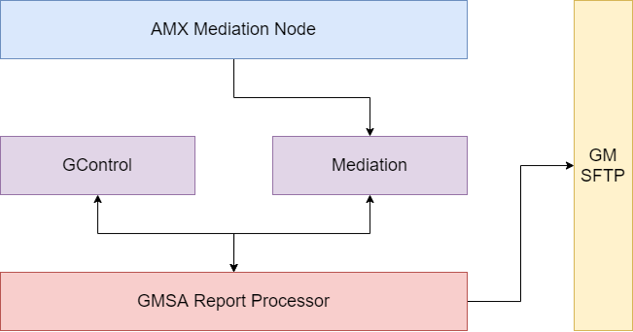

# GMSA Reports

## Data Report



## Voice Report



## Successful SMS



## Mobile Number Reconciliation



## Monthly Recurring charges(Later Phases)



# BIG Invoice









# Report Processing Method

1. Globetouch will generate zip files at midnight UTC and send through sftp to GM folder
2. Each zip file will contain ctl, eot and csv files
3. Csv files will contain reports data for each country
4. Eot file will contain the ctl file name and all the csv files name comma separated
5. For every ctl file row, each csv file name with total number of records in that csv file will come

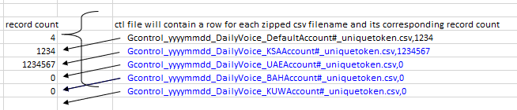

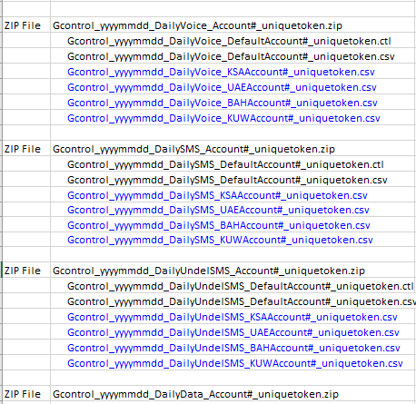



About Airlinq

At Airlinq, we envision a thriving ecosystem of people, businesses, and cities that are related, safe, and efficient.

We strive to enable and empower our customers and partners in defining the present & future of their products and services in a way that presents an open road of possibilities.

Such an objective, drives highly efficient information exchange and decision making supported by insights that have never been available before.

Connected ecosystems of tomorrow will present tremendous monetization opportunities for automakers, connectivity service providers, enterprises and numerous new avenues for customer engagement.

Airlinq Inc.

2200 Camino Ramon Unit B, San Ramon, CA 94583

[www.airlinq.com](http://www.airlinq.com)

info@airlinq.com